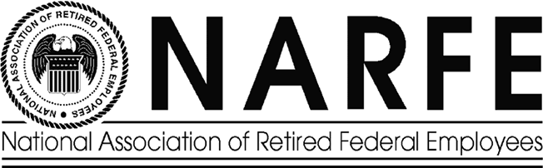

THE 740 EXPRESS
OFFICIAL NEWSLETTER NATIONAL ASSOCIATION OF RETIRED FEDERAL EMPLOYEES, CHAPTER 740

www.crompton.com/NARFE740

April 12, 2002
Officers:
President: Max Schwartz, 111 Meade Rd., Elkins Park, PA 19027 215-635-3209
Secretary: Archie C. Ashley, 111 Devon Rd., Chalfont, PA 18914 822-9421
Treasurer: Isolde W. Porsche 211 Autumn Leaf Dr. Doylestown, PA 348-0463
Newsletter Editor: Norman D. Melling, 17 Hillside Lane, Doylestown, PA 18901-2901 345-7939
Communications Director John DeMatteo 621 W. Sandy Ridge Rd., Doylestown, Pa.18901-2127 345-9033
Telephone Com. Coord.: Teeny Lacher 5 Broadale Ct., Doylestown, PA. 18901 345-9098

Next Chapter Meeting: 1 PM Thursday APRIL 18, 2002
WHERE: Giuseppe’s Pizza & Restaurant in Warminster
(215-674-5550)
PLEASE CALL TEENY AT 215-345-9098 IF YOU PLAN TO ATTEND.
We welcome all Federal Retirees. Encourage your fellow retiree to attend. Bring your spouse!

Max Schwartz, John DeMatteo and Norman Melling will attend the NARFE Convention in Valley Forge on May 6 – 8. We want to know what you are interested in, so we can represent your interests at the conference. Please plan to attend our next meeting on April 18th and show your support. We want you to be involved and participate in NARFE 740 efforts for our retirement activities. We need new members to take actions and participate in activities. Look at the NARFE website (www.NARFE.org), the “Retirement Life,” or our previous newsletters (www.crompton.com/NARFE740) for issues that you want our chapter or NARFE HQ to respond to. Let us know what you think about these issues. Send us an e-mail, or better still, attend on April 18th and tell us yourself.

If you have access to the Internet we recommend that you sign up for the FEDWEEK newsletter (http://www.fedweek.com) to obtain helpful information for retirees. We plan to order the “Trustees Handbook to have available to chapter 740 members to browse. Do you have any other helpful “links” that should be brought to the attention of our members? Please let us know about them, so we can post them and share the information that will provide good guidance to make good decisions on retirement matters.

FEDERAL -- LONG TERM CARE INSURANCE The following information is provided from Sam Girson, NARFE NFVP, Region II
There will be an early LTC enrollment from March 25-May 15, 2002 and the regular Open season will start July 15-December 31, 2002. My suggestion to you, if you are not fully knowledgeable about LTC, is to wait (unless there is a reason to sign up early) for the regular open season when educational material will be available. Also, more information will be published on LTC in forthcoming issues of “Retirement Life.”
One word of caution! John Hancock and Metro Life are the authorized partners who are the official agents for the federal LTC insurance program. Make sure when you are talking with a John Hancock/Metro Life agent they are authorized to sell “federal” LTC insurance.
For further federal LTC information call 1-800-582-FEDS (3337) or use Website: http://www.ltcfeds.com
CONGRESSIONAL CONTACTS
The Honorable Arlen Spector: Rm. 530 Hart Senate Office Bldg. Wash, DC 20510(215-597-7200 & 202 224-4254)
The Honorable Rick Santorum: B-40 Dirkson Senate Office Bldg. Wash. DC 20510(215-684-6900 & 202-224-6324)
8th District, Congressman Jim Greenwood: Rm. 515 Cannon House Office Bldg. Wash. DC 20515 (215-348-7511 & 202-225-4276)
13th District, Congressman Joe Hoffel: Rm. 1229 Longworth House Office Bldg. Wash. DC 20515 (610-272-8400 & 202-225-6111)

Office of Personnel Management, Wash DC 20415 (1-88-US-OPM-RET=1-888-767-6738, or 202-606-0500)
OPM Retirement Operations Center, Boyers, PA. (714-794-5216)
Don’t forget to keep your spouse informed about your annuity!

Doylestown Chapter 740, NARFE

Max Schwartz, President

111 Meade Rd.

Elkins Park, Pa. 19027-2218

ADDRESS CORRECTION REQUESTED

