THE 740 EXPRESS
OFFICIAL NEWSLETTER NATIONAL ASSOCIATION OF RETIRED FEDERAL EMPLOYEES, CHAPTER 740

www.crompton.com/NARFE740

March 1, 1999
Officers:
President: Max Schwartz, 111 Meade Rd., Elkins Park, PA 19027 635-3209
1st Vice President: Stanley A. Vekteris, 3549 Buttonwood Dr., Doylestown, PA 18901 348-2180
Secretary: Archie C. Ashley, 111 Devon Rd., Chalfont, PA 18914 822-9421
Treasurer: Beryl Fogelsanger, 600 Valley Rd (D13), Warrington, PA 18976 343-3467
Publicity: Lemuel W. Dicks, Scott Rd., Box 618, Perkasie, PA 18944 766-0838
Newsletter Editor: Norman D. Melling, 17 Hillside Lane, Doylestown, PA 18901-2901 345-7939
Communications Director John DeMatteo 621 W. Sandy Ridge Rd., Doylestown, Pa. 18901-2127 345-9033
Telephone Com. Coord.: Tinna Lacher 5 Bradle Ct., Doylestown, PA. 18901 345-9098
Next Chapter Meetings:Our next meeting will be on Thursday March 18, 1999 at the Warrington Motor Lodge, Route 611 (just North of Street Rd.) at 12:00 Noon. Call Beryl Fogelsanger (343-3467) early in the week. Please attend and show your support.

REMINDER February 18, 1999 Chapter Meeting:
Thomas E. Willey will present a lecture on TRUSTS. This is particularly an important subject for seniors who are leaving estates and would like to minimize taxes and legal fees, and maintain control over their money during their lifetime. Questions and Answer period follows. Attend
this presentation, it may save money and grief.
March 18, 1999 Chapter Meeting: “LONG TERM HEALTH CARE”
1. The presenter is Bill Potashnick. He is a volunteer presenter for the Area Agency on Aging (AAA).
2. He speaks on many subjects that we should be interested in. He is licensed by Harrisburg to present these subjects. We probably have Bill for future meetings.
3. The subject presentation will consist of a very brief description on what AAA does along with appropriate handouts, followed by a presentation on Long-term Care.
4. The main purpose of the presentation is to answer the questions, “Should I get long-term care?”’ “If so, which one?”
5. In addition to background material on the subject, all present will receive individual and private work package intended to help in the decision making process
- There will be a question and answer period.
Congress under HR110 & S57 would make Long Term Health Care benefits to be available to federal employees and retirees. OPM would design the benefits package. Stay tuned in!
The President’s budget for fiscal year 2000 “proposes to provide a new long-term care tax credit of $1,000. The credit could be claimed by a taxpayer for himself or herself or for a spouse or dependent with long-term care needs.” The credit would be non-refundable. It would fund the administrative costs associated with establishing a new federal employee and retiree long-term care insurance benefit. The group rates would be from 10 to 15 percent cheaper than comparable policies for individuals. Participants would pay the full premiums. There would be no government share.

NECROLOGY: Please let us know when you hear that one of our honored members has passed on, so we can share it with friends and associates. Remember them, their spouses and families with memorials and appreciations for their accomplishments and duty to the United States. Please note: John Sispera of Edwinna, PA passed away on June 10th, 1998.
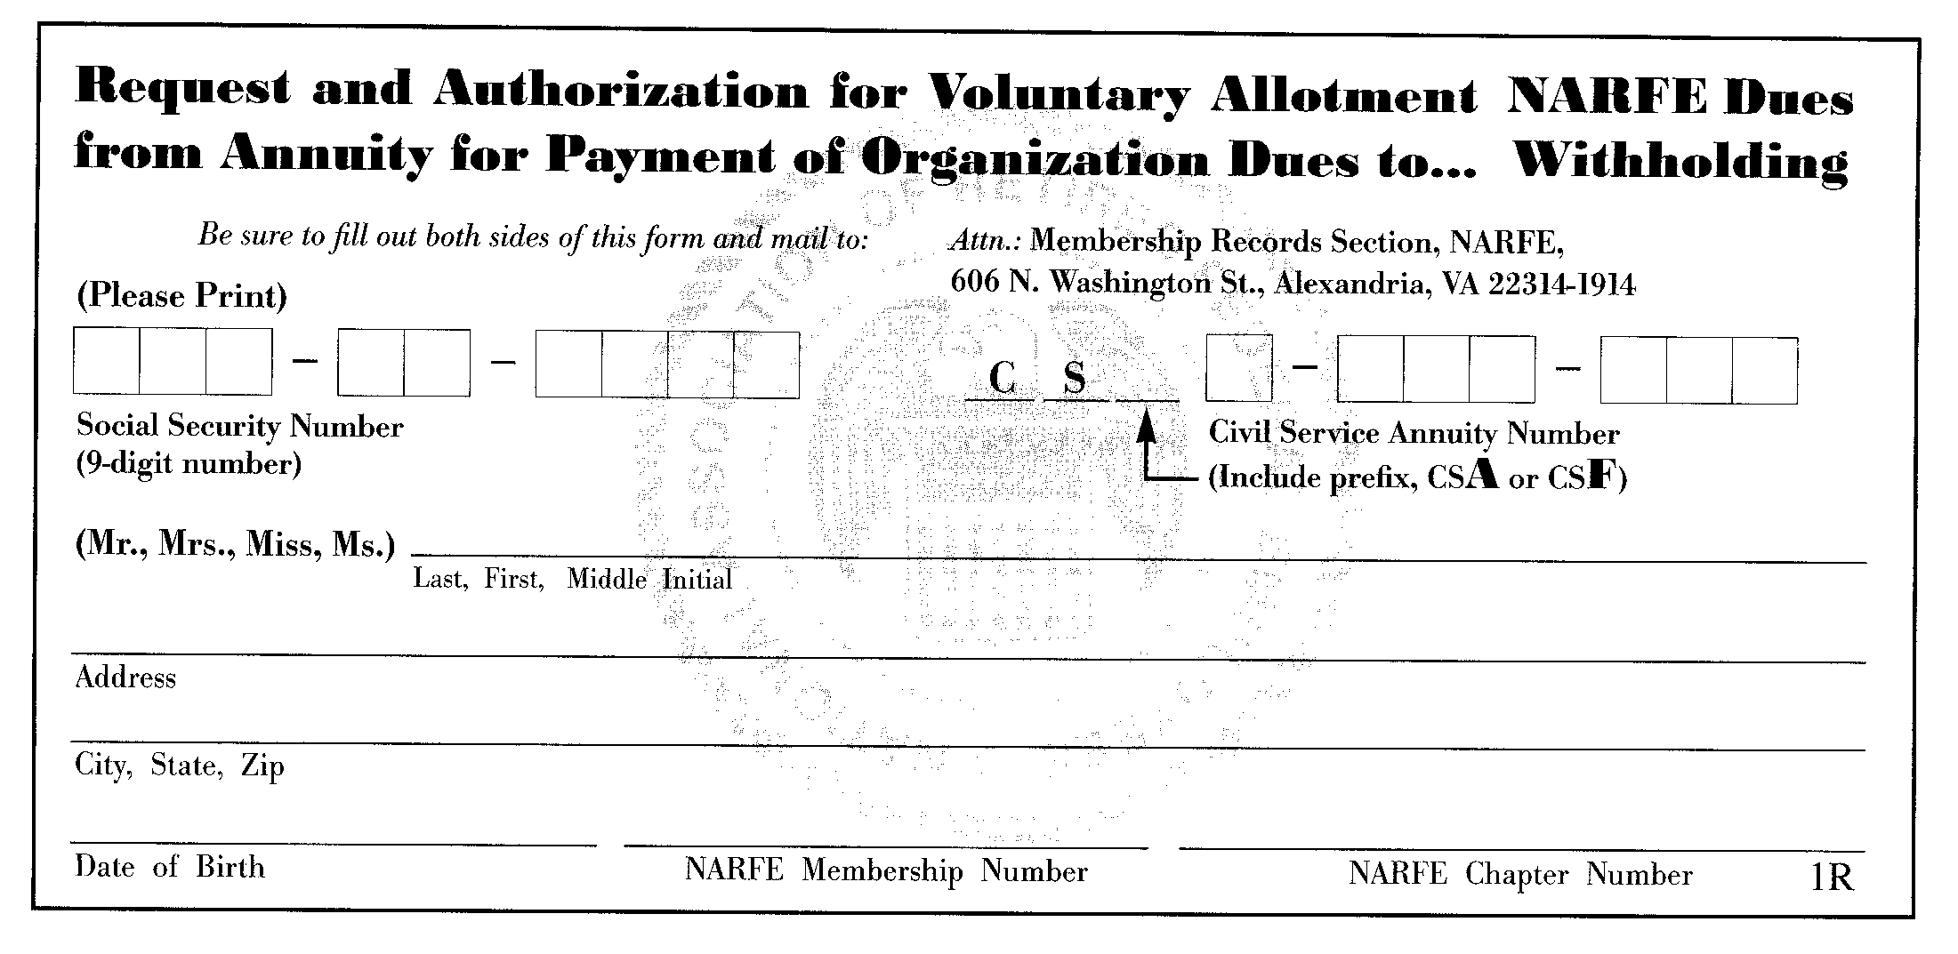

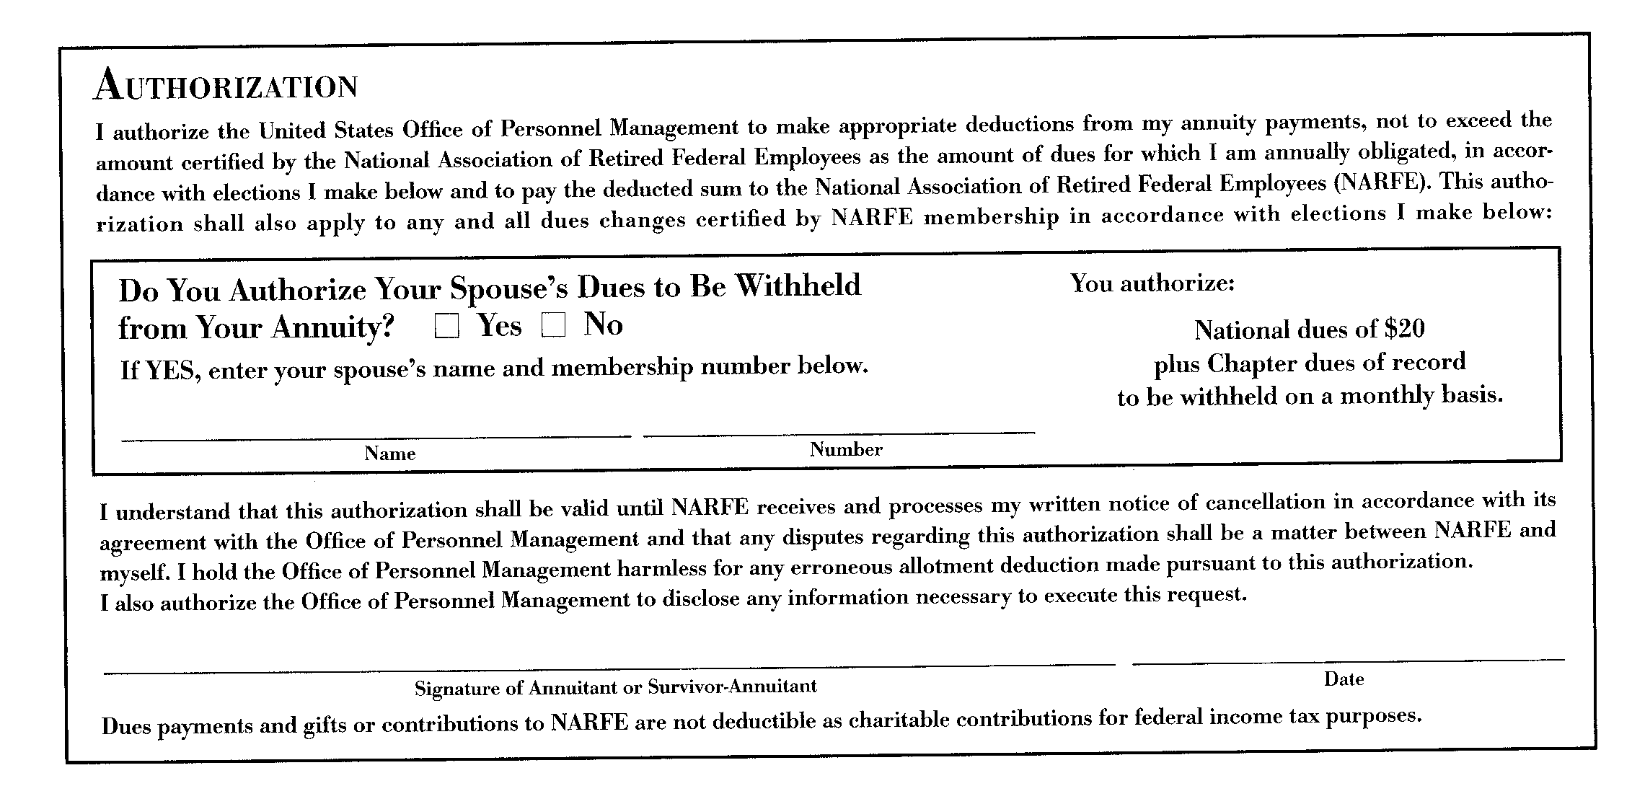
Obtain a reimbursement for your entire NARFE Dues. Fill out the above form, cut at the dotted line and mail to:BERYL FOGELSANGER
*** SPECIAL NOTICE ***
In accordance with information promulgated by the Pennsylvania State Federation (NARFE), any NEW or EXISTING member of this Federation (which includes DOYLESTOWN CHAPTER 740 (NARFE) will be REIMBURSED THE FULL COST of the first year membership dues by the State Federation if you apply for dues withholding. In instances where the annual dues have already been sent, dues withholding application should also be submitted to BERYL FOGELSANGER, TREASURER, Doylestown Chapter 740, 600 Valley Road (Apt-13), Warrington, PA 18974-5308. Arrangements will be made by our CHAPTER for the reimbursement.
MEMBERSHIP: Please encourages your fellow Federal retirees to join and retain membership in NARFE Chapter 740. Our chapter seeks strong, involved members so we can support legislation that will strengthen our retirement. Remember that your spouse is encouraged to become a member. Spouse members will also benefit upon becoming survivors. Our Chapter represents both the retiree and spouses, both are invited to join and participate.

Free LTC Insurance Article: (http://www.fedweek.com) An article on the ins and outs of buying this relatively new kind of insurance that is designed to help offset the dollar-intensive care of your loved ones. Just go to the Fedweek home page and click on the text at the top of the page and you’ll be whisked to the item, which you can read, print out and pass around.

Alert! Time is running out to apply for the Homestead Tax Exclusion. Deadline is March 1,1999
NARFE Chapter 740 advises our members to consider applying for the Homestead Exclusion. What this means is if the Local school board votes later this year to approve the act then those who have applied will be eligible for a Tax relief. The Homestead Act allows homeowners to choose to have the Tax on their home lowered on the basis that the homeowners are taxed on their earned income. This exclusion could be very beneficial for retirees whose income is annuities, which is not taxed.

Doylestown Chapter 740, NARFE

Max Schwartz, President
111 Meade Rd.
Elkins Park, Pa. 19027-2218

To:

